WL-6203-V1 WLAN 11n Dongle (1T2R,WPS)
CC&C

WL-6203-V1 is a WLAN 11n Dongle, which fully supports the features and functional compliance of IEEE 802.11n,e and i standards. It supports up to 300Mbps high -speed wireless network connections.
It is designed to provide excellent performance with minimum power consumption and enhance the advantages of robust system and cost-effective; With Build-in WPS button to simplify the process of configuring security on wireless networks. It is targeted at competitive superior performance, better power management applications.

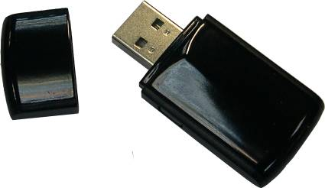

FEATURES
- Operates in 2.4 GHz frequency bands
Freq. | Frequency
2.4 GHz | 2.312-2.472 GHz,
 | 2.484 GHz

- 1x2 MIMO technology improves effective throughput and range over existing 802.11 b/g products
- Data rates: up to 300Mbps
- WPS button (Wi-Fi Protected Setup) for easy and secure establishment of a wireless network.
- 802.11e-compatible bursting and I standards
- BPSK, QPSK, 16 QAM, 64 QAM, DBPSK, DQPSK, and CCK modulation schemes
- WEP, TKIP, and AES, WPA, WPA2 hardware encryption Schemes

CC&C TECHNOLOGIES
8F, No. 150, Jian Yi Road, Zhonghe District,
New Taipei City, Taiwan 235, R.O.C.
Tel : 886-2-8226 5088
Fax : 886-2-8226 5077
marketing@ccandc.com.tw

SPECIFICATIONS

Specifications are subject to change without notice

